Title here (Arial, bold, 14 points, justified)

Author 1ª, Author 2^{b},… (Arial, 12 pt, justified, Presenting Author underlined)

ªAffiliation 1; ^{b}Affiliation 2…(Arial,italics, 12 points, justified); email: first.second@domain.edu

Body text (Arial 12 points, justified; 1,0 line spacing).references, if any, in superscript with Arabic numbers

(up to one figure can be added to the abstract; centered with caption below)

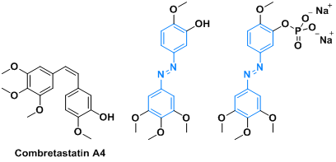

Figure 1. Caption (Arial, 10 pt, centered)

References
- Arial, 10 pt, sequentially numbered in Arabic, justified, ACS style is suggested, i.e: Author, A.; Author, B. Journal Acronym year, volume, initial page-final page.
- …

Acknowledgements
Arial, 10 pt, justified

Please keep to a single page

