FULL TITLE (Calibri 14)

Presenting Author (Calibri 10 Bold)¹, Co-Authors² (Calibri 10)
¹Organization, Address, City, Country (Calibri 9)
²Organization, Address, City, Country (Calibri 9)

Contact@E-mail (Calibri 9)

Abstract (Calibri 10)

ONE page abstract format: two pages maximum including figures and references.

Do not change the font sizes or line spacing to squeeze more text into a limited number of pages.
Please follow the model below.

Single-spaced and a single paragraph.

Greek letters, sub- and superscripts should be formatted as such.

References

- Authors, Journal, Issue (Year) page (Calibri 10) Indicate references with sequential numbers within [square brackets].
- Authors, Journal, Issue (Year) page (Calibri 10) Indicate references with sequential numbers within [square brackets].
- Authors, Journal, Issue (Year) page (Calibri 10) Indicate references with sequential numbers within [square brackets].
- Authors, Journal, Issue (Year) page (Calibri 10) Indicate references with sequential numbers within [square brackets].

Figures

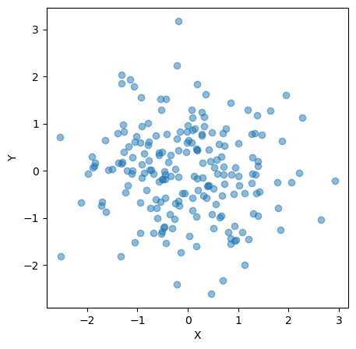
Figure 1. Insert caption to place caption below figure (Calibri 9)

